PSK31 Link Budgets for Psat, BRICsat and USS
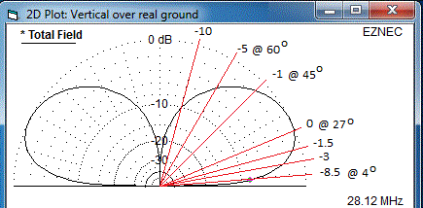
Mission Uplinks: The PSK31 mission is to provide a real-time link system for up to 30 users to share a communications event. All users transmit simultaneously during the pass on their own selected 60 Hz segment of the FDMA uplink passband (28.120 to 28.123 MHz) and receive all downlinks simultaneously in a 3 kHz passband using a UHF FM receiver.
User Ground Stations: Users are requested to configure their stations as actively manned uplink stations, transmitting with a single ¼ wave vertical omni antenna and a 5W transmitter. The vertical elevation profile of the gain pattern is as shown here with a 3 dB beamwidth from about 10 to 55 degrees. Users are also assumed to be using a high gain UHF tracking receive system for receiving the downlink for best results.
Orbits are assumed to be 350km to 800km circular or elliptical. At 800km worst case, the slant range at 4 degree elevation is 3000km. The following scale drawing is actually for a lower 400km orbit but sufficiently shows the drastic effect of elevation angle on range gain (and percentage access times) of a typical LEO orbit.
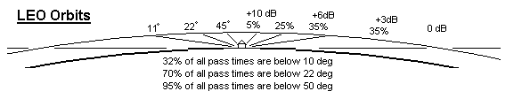
Range and Antenna Pattern Gain: This is an artificial adjustment for range for the 800km orbit altitude using the 3000km at the 4 degree horizon as a baseline. It also includes an elevation adjustment for the 0 dB gain of the user transmit vertical monopole at 27 degree elevation. Additional columns show the effect of the range gain, pattern gain and then the combined gain as observed at the spacecraft receiver.
Range Range Gain Pattern Gain Combined
------------------------------ ----------------------- -------------------- -------------
3000 km Horizon 0 dB (reference) -9 dB at 4 deg -9 dB
2500 km Horizon +1 dB (reference) -2 dB at 4 deg -2 dB
1500 km (above 27 deg + 6 dB 0 dB at 25 deg +6 dB
1000 km (above 45 deg) + 9 dB -5 dB at 60 deg +3 dB
Antenna Gains: The four typical antennas for the PSK31 missions are the omni antennas on the spacecraft, the vertical monopole for the HF user uplink and the high gain UHF receiver antennas for the user downlink receiver:
Spacecraft UHF Transmit antennas 0 dBi monopoles
Spacecraft HF Receive Monopole - 6 dBi monopole with losses (main unknown?)
User Transmit Antenna 0 dBi vertical monopole over ground (0 to -5 dBi)
User Receive Antenna +15 dBi tracking gain antenna

Receiver Thresholds: The following thresholds are assumed for 90% reliabilty (measured test data on the Kenwood TH-D7A handheld and TM-D700 mobile/base radios)

-122 dBm UHF user receiver (for 10 dB SINAD spec)
-140 dBm HF Psat receiver for minimum detectible signal (measured by Brno University)

Link Budgets: The link budget uses the simple equation in dB as shown here for the power received (Pr) with a given transmitter power (Pt), Transmitting antenna gain (Gt), Receiving antenna gain (Gr), incidental losses (Li) and space loss (Ls). For reference we will make preliminary calculations assuming the worst case 3000km range.
Pr = Pt + Gt + Gr –Li – Ls where Ls = ((4*Pi*R)/lambda)^2

SpaceLoss at 435 MHz: Ls = 154.6 dB
SpaceLoss at 28 MHz: Ls = 131.5 dB

USER UPLINK (28 MHz) TX power 5W: Pr = 34dBm +0dBi -6 dB – 3dB – 131.5dB
Pr = -106 dBm
RX threshold = -137 dBm (derated 3 dB from spec)
Margin = 22 dB at horizon ( 4 deg)
Margin = 29 dB at horizon ( 10 deg)
Margin = 37 dB at 27 deg elevation
Margin = 34 dB at 60 deg elevation

User PSK31 waterfall UHF FM Downlink: Pr = 30dBm +0dBi +15dBi – 3dB – 154.6dB
Pr = -112.6 dBm
RX threshold = -119 dBm (derated 3 dB from spec)
Margin = 6.4 dB at horizon
Margin = 12.4 dB at 27 deg elevation
Margin = 15.4 dB at 60 deg elevation

Summary: The uplink power per station with the given vertical omni antenna will vary by about 9 dB over the duration of a pass. The downlink receive margin will be good at the horizon and very good above 10 degrees with a high gain beam. It will even be receivable for a minute or so on a handheld with rubber duck above 30 degree elevation.
Azimuth-only UHF Downlink Tracking Antennas: From the previous graphics, it is apparent that the maximum receiver gain is only needed at the horizon. Therefore, just a simple beam antenna on an inexpensive ($80) TV rotator is sufficient. By fixed-tilting the antenna up to about 15 degrees, then maximum gain is still maintained on the horizon while still providing more than adequate gain at all higher angles when the beneficial effects of the closer range gain is included as shown in the below graphic:
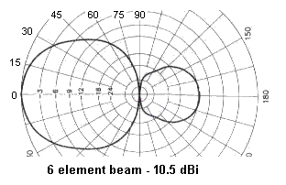
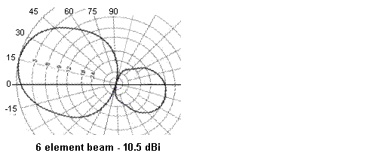
The following table is a plot of overall gain of the up-tilted 15 degree antenna for the elevation angles shown. Tilting an antenna any higher than about 15 degrees will sacrifice gain where you need it most on the horizon, and give you additional gain where you need it least. Of course, if you cannot see the horizon from your location, then a higher up-tilt makes sense, but then, a smaller antenna probably 3 or 4 elements will do.
EL % CUM-% RANGE RNG-GAIN ANT-GAIN OVERALL-GAIN
--- --- ----------- ----------- ---------------- ---------------- ------------------------
10 32 32 3030 0 10 10
20 35 67 2440 2 10 12
30 17 84 1827 5 9 14
40 8 92 1460 6 7 13
50 4 96 1190 7 6 13
60 2 98 1020 9 3 12
* Data for an 800 km orbit. For the ISS at 370 km, the times below 30 degrees are 6% higher.
* If your horizon is blocked below 5 degrees anyway, elevate the beam to 20 deg to improve gain (+2 dB)

