Community Solar - A Maryland MDOT, SHA, MDE, MEA, PUC Initiative:
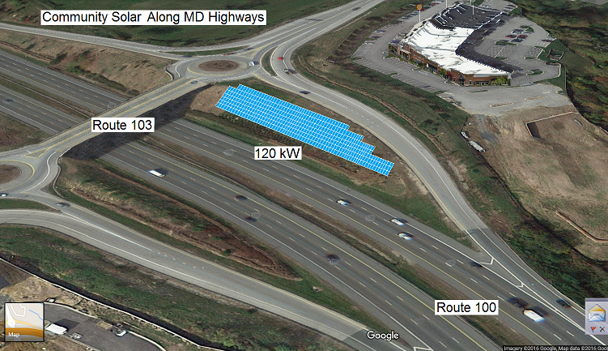
The MD-EVIC council’s mandate of clean renewable transportation in Maryland, includes the perfect marriage of EV’s running on clean renewable Solar energy. As such, the council has broad representation across all state agencies and is in a unique position to effect initiatives in community-solar already signed into law.
But the number one hurdle to community solar is where to put them. Land is scarce and structure owners want their own roofs for their own solar.
The MDEVIC should explore the possibility for practical/available land in the trapped & isolated pieces in-and-along highway state rights-of-way. An example of the interchange between Route 100 and 103 just west of I-95 is shown here. This is a win-win-win for the state, for shaded rate payers and for the environment:
• Suitable SHA right-of-way lands exist
• Such land is often already cleared, fenced and secured in most cases
• Solar panels can reduce existing mowing and landscape maintenance
• Solar panels can reduce run-off when combined with water collection
• Hill cuts and berms with slopes are twice as effective as flat land for solar panels
• The power would be broadly distributed throughout the state
- Rate payers with shade are more than willing to buy-in to get clean power for their EV’s
• This clean energy project could be paralleled with EV promotion initiatives
• This example could power two dozen homes or thirty 40-mile daily commuting EV's for life
But most importantly, this MDOT viable community solar involves EVERYONE:
- It eliminates the contention between Sunny-have's and Shady-have-nots in the political discourse! It defuses the contention over net metering.

- It puts the future of solar energy in plain view of everyone where we live and drive.
This proposal begins with MDOT and SHA to identify suitable square footage and then the other agencies to explore ways to make it happen. Surely, Maryland can do better than New Jersey’s ugly one-panel-per-power pole concept.
Sincerely, Bob Bruninga, PE
IEEE National Committee on Transportation and Aerospace
410-293-6417, bruninga@usna.edu
http://aprs.org/MD-community-solar.html

