A possible Radio GoKit for ARISS School Contacts?
(rev-d) 20 Oct 2015
Bob Bruninga, WB4APR
Bruninga@usna.edu
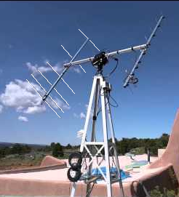
This paper explores the idea of a "go-kit" for facilitating the equipment setup for schools participating in an ARISS contact with the ISS crew that may have difficulty configuring a full OSCAR class station.

AZ/EL Tracking Challenge: The challenge for these contacts is the need for horizon-to- horizon antenna coverage and the difficulty of getting the cables between the operating position (usually in a large room to accommodate a large number of students) and the antenna location usually separated by 100 to 200 feet. In the past, the goal has been to establish an OSCAR class antenna with full AZ/EL antenna capability, orbit tracking and Doppler tuning as shown at right.

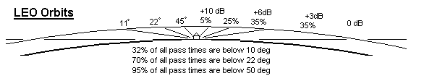

Simpler Multi-Antenna Approach: This paper explores another possibility for simplifying the equipment reauirement to something that can possibly fit in a GoKit. The idea is to place modest gain antennas and receivers on both the AOS side and LOS sides of the school building for best horizon coverage and then use a simple turnstyle omni for the uplink and reception during the stronger middle of the pass when the signal is 10 dB stronger and moving rapidly. Looking at the actual geometry of a typical overhead pass drawn to actual scale as shown above, it is easy to see that the ISS spends over 70% of its pass time near the horizon and below 30 degrees and only a few minutes above 30 when it is closest and strongest.

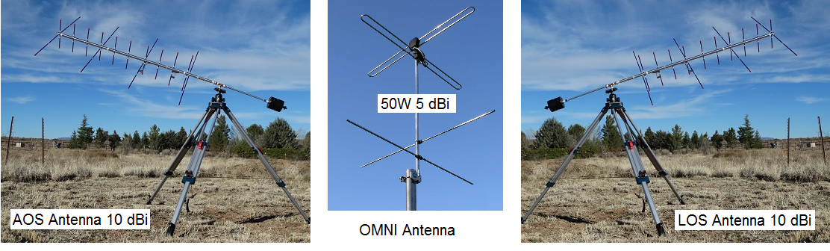

This simple tri-antenna approach provides similar antenna performance as the full size OSCAR array system but eliminates the long yagi, the az/el rotator and tracking and the need to place all of that at the highest location. But most importantly, it eliminates all the long coax runs.

Eliminating the Coax Runs: The coax problem is solved because all of the antenna systems are implemented using dual band radios as cross-band repeaters as shown below. These transceivers then need no coax more than a few feet and transmit their reception deep into the school building in almost any venue. Not only does it eliminate the hundreds of feet of coax, it also eliminates the need for a separate LNA and Power Amp since coax loss is eliminated by having the transceivers right at the antenna.
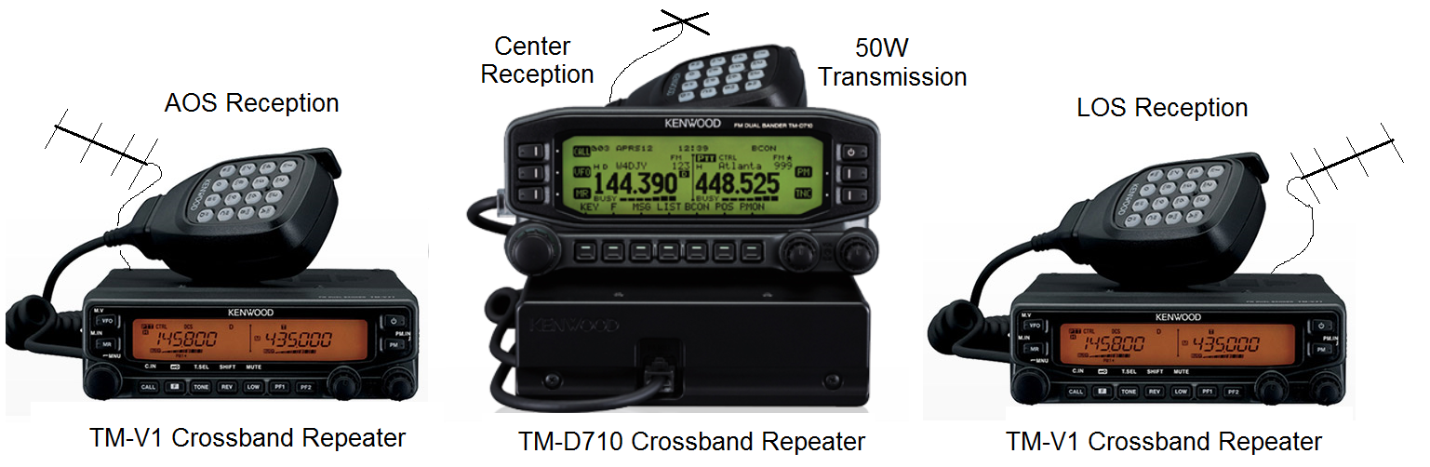

The uplink similarly uses a crossband radio as the uplink transmitter located at the base of a good omni antenna (no coax loss) with a 12v battery of sufficient capacity for the event. There are no wires to the indoor location, just another UHF link. The big advantage of this uplink antenna is that since it only has to serve the center high elevation portion of the pass, then it is much easier to locate and install where the sky is very visible.

Power Supplies: A 7 Ah 12v battery is sufficient for a possible hour of operation at each radio and they can be backed up by simple 1 amp trickle chargers with convenient extension cords to the nearest wall outlet for long period operation as needed.

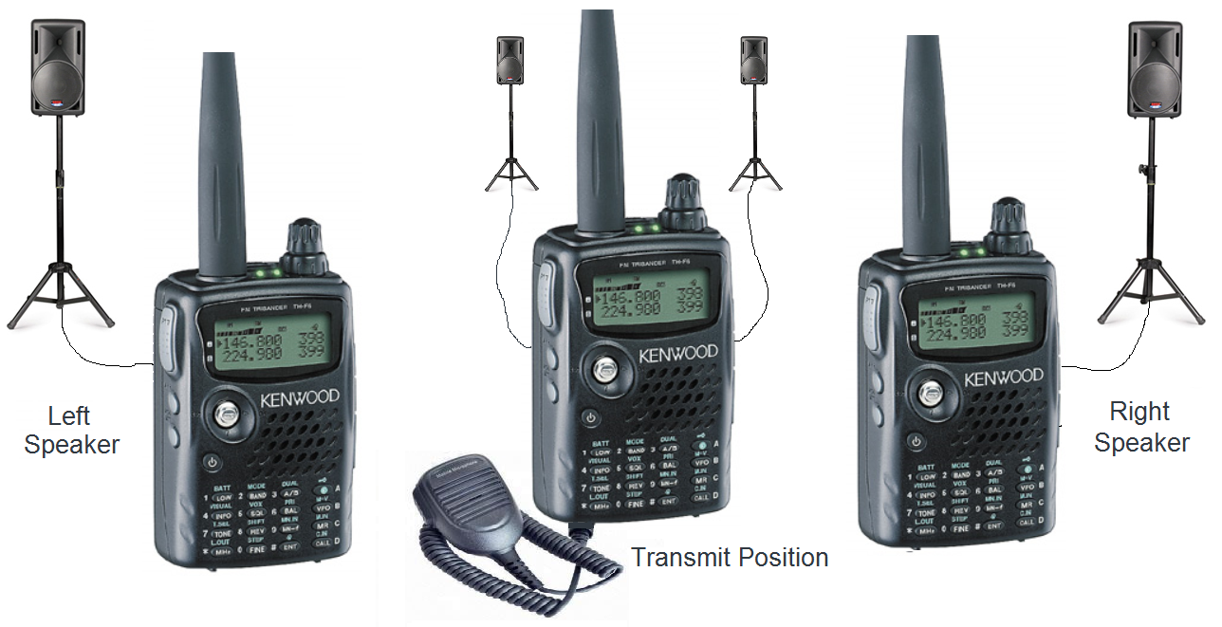
Inside Operating Position: Inside the auditorium or cafeteria, the only radio systems required are three UHF walkie-talkies coupled into the sound system. One transmits to the UPLINK cross band repeater. And all three listen to the ISS downlink via the crosslinks of the AOS, LOS and central receivers. Each crosslink is on a separate frequency so they operate independently and do not conflict when more than one receiver is hearing the downlink audio. In the diagram above, only the center radio link is configured for transmit, since the 50W mobile radio has a 10 dB uplink advantage over the weaker ISS handheld 5W downlink. But if testing warrants it, any of the three UHF walkie-talkies can be used to transmit.

Speakers and Squelch Operation: Do NOT run open squelch. Set the squelch for normal ham radio operation to silence the radio when the signal would be unintelligible anyway, since we would not want unintelligible noise from one receiver to distract from good audio from the possible others.
Having three receivers also provides system improvement through the spatial diversity. The concept is to bring in all three receiver speakers (left-to-right) into the auditorium operating position to give equal weight to each receiver but also give a sense of the passage of the ISS left-to-right during the pass. During this test, It is tempting to want to re-orient or move your AOS (or LOS) beam, but we need the data horizon-to- horizon on the original fixed antenna orientation to see how well the antenna works in its part of the sky and how well its squelch eliminates the distraction of a noisy receiver when it is not the prime contributor.
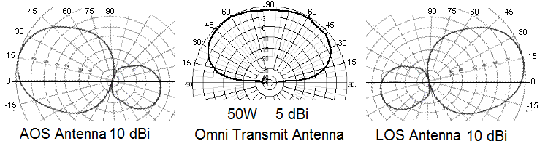

Beam Antenna Vertical Orientation: The beams are mounted for vertical polarization since the Ham antenna on ISS is more-or-less vertical. As shown in the antenna plots above, the AOS and LOS antennas should be tilted no higher than 15 degrees in elevation. This provides less than 1 dB loss at the horizon (which it likely cannot see anyway) but still provides full gain all the way up to 30 degrees where the ISS is 3 times closer and 10 dB stronger. At these higher elevations, the cross polarized omni antenna (turnstyle) should serve nicely since it has a broad pattern upward. It is easy to see how in a horizon-to-horizon overhead pass, the plots above show the ISS always in the main beams of the antennas.
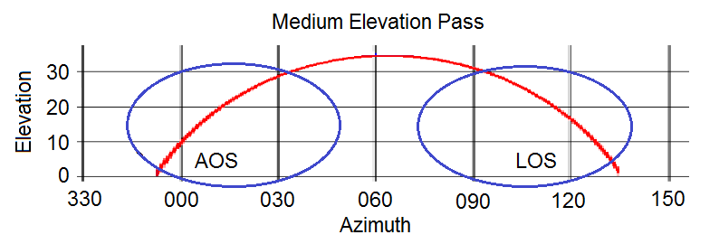
Beam Antenna Azimuth Pointing: For modest elevation passes where the pass is not overhead, but passes the school mostly to one side as shown above , still the beams do not need to be moved during the pass. By always pointing the fixed AOS and LOS beams to an azimuth that is half-way between the horizon AOS (or LOS) and where the ISS crosses about 30 degrees elevation, then the spacecraft is either well within the beams, or is above 30 degrees(and stronger on the omni antenna) at all times during the pass.

Feasibility Test Phase: The purpose of this preliminary paper is to present enough of the concept to make it possible to suggest a test phase that is independent of any school contacts but can allow any of our many skilled AMSAT portable satellite operators with arrow-type portable beams to gather the data needed to see if this approach is feasible. They can do their own test during any school contact pass as long as they share at least the AOS or LOS with the footprint of the pass.
The desired data would be a minute-by-minute log throughout the pass of ISS signal quality especially noting any nulls or fades without moving or adjusting the antenna. Just orient the beam vertically with an uptilt of 15 degrees. Then aim it at an Azimuth half way between AOS (LOS) and where the ISS will rise above (drop below) 30 degrees elevation to cover the first (or last) portions of the pass. The beam is not needed above 30 degrees where the ISS is 3 times closer and 10 dB stronger and can be heard fine on the central omni.
An audio recording would make it easier to prepare the log after the pass or you can just make checks or X's every 5 seconds on a piece of paper and summarize it later. It would be nice if you could add the actual AZ/EL of the pass for each data point if possible.
Conclusion: If this test shows any promise, it could not only eliminate all the complexities of long crossed yagis, AZ/EL rotators, big masts and active tracking, but also completely eliminate the problem of long runs of coax from the school gymnasium to the antennas. The coax is eliminated by placing 50W mobile rigs (capable of cross band repeat) at each of the possible three antennas and operating them remotely via 3 UHF HT's indoors on-stage (coupled into the sound system).
So, if there will be an ISS school contact within range of your station, and you have an arrow on a tripod at your QTH, you could collect data to see if this idea is a possibility. Again, this is *independent* of the actual school contact, you are just taking your own receive data where ever you are of how well an arrow on a tripod can hear the ISS at low elevations. Be sure to find a place with a good horizon at AOS(or LOS) to set your antenna.
I'm on deadline to deliver a satellite in 12 days, and so if someone else might be interested in collecting and summarizing any incoming reports, that would be helpful too.
If we learn that there will be any significant fades or loss of signal, then this idea fails... But if it works, then the two arrows, tripods, three mobile rigs and three UHF HT's could be made into a suitcase GOKIT to standardize school contacts with a lot less work.
Doppler Tuning Concepts: Another phase of this test will be to see if we can eliminate the +/-2.5 kHz Doppler tuning while still keeping within the bandwidth of the Erriccson Radio. This is possible if the School Ground station can switch to Narrowband modulation. This is possible under the RADIO/AUX menu of the Kenwood radios. This test will need crew participation to see if the lower audio of narrowband operation can still be heard in the headset.
If this does not work, then we can investigate if the AOS and LOS kenwood radio synthesizers can be shifted 2.5 kHz. Then the AOS one can be set 2.5 kHz low and the LOS one 2.5 kHz high. This compensates for Doppler during the pass as the signal strength switches from radio to radio.
Just an idea
Bob, WB4APR

